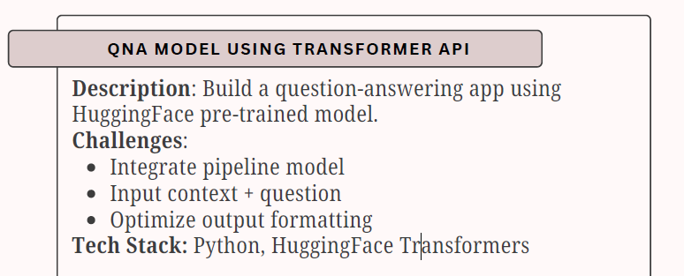

TASK-2

Project Overview
A Question Answering (QnA) system is a Natural Language Processing (NLP) application that automatically answers user questions based on a given context/passage.
In this project, we build a QnA application using Hugging Face Transformers and its pipeline API, which allows quick integration of pre-trained transformer models.

What is a Transformer?
A Transformer is a deep learning architecture designed to handle sequential data (like text) efficiently using an attention mechanism instead of recurrence.
Key Advantages:
- Understands context and meaning
- Handles long text efficiently
- Enables parallel processing
- Forms the backbone of models like BERT, RoBERTa, GPT

What is the Transformer Pipeline API?
The Hugging Face Pipeline API is a high-level abstraction that simplifies:
- Model loading
- Tokenization
- Inference
- Post-processing
Why use Pipeline?
- No need to manually load tokenizer and model
- Minimal code
- Ideal for prototyping and demos

Question Answering Task (Theory)
Type Used: Extractive Question Answering
- The model extracts the answer directly from the context
- It does not generate new text
- Commonly trained on datasets like SQuAD
Input:
- Context → Paragraph or passage
- Question → User query
Output:
- Answer text
- Confidence score
- Start and end positions (internally)

Model Used
📌 distilbert-base-uncased-distilled-squad
Why this model?
- Lightweight and fast
- Fine-tuned on SQuAD dataset
- Good balance between speed and accuracy
- Suitable for CPU-based execution

System Architecture
User Input
(Context + Question)
↓
Hugging Face Pipeline
(Tokenizer + Model)
↓
Model Inference
↓
Formatted Answer Output

Key Challenges Addressed
1. Integrate Pipeline Model
- Used pipeline("question-answering")
- Automatically handles preprocessing and inference
2. Handle Context + Question
- Ensured both inputs are mandatory
- Structured input dictionary:
- {"context": context, "question": question}
3. Optimize Output Formatting
- Removed unnecessary fields like start/end indexes
- Displayed only:
  - Answer
  - Confidence score (optional)
- Improved readability for users

